Faculty Profile

Name: Sri Subrata Roy 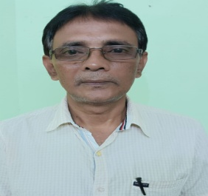
Designation: PGT HE
E-mail: rsubrata323@gmail.com
Date of Joining in Service: 01.07.2010

Qualifications: M.Com.

Subject: Commerce
Specialization: Finance & Accounts

